**Title of the paper: single spaced, Times New Roman, 14 point bold font and centered**

**Presenting Author**1, Second Author2, and Third Author3

*1 Affiliation of the presenting author (11pt, left justified, italic)*

*2 Affiliation of the second author (11pt, left justified, italic)*

*3 Affiliation of the third author (11pt, left justified, italic), leave two blank lines after author’s affiliations.*

Author list: Times New Roman 12 pt. centered. The **presenting author** is in bold.

If your abstract is submitted as a Microsoft Word file (“.doc”, or “.docx”), use a 12 point Times New Roman font and 1.15 spacing between lines. Do not indent paragraphs. Use justified formatting for the text. Please do not modify the layout of the template. The paper format should be A4. Document margins should be 2.5 cm top and bottom, and 2 cm left and right.

Abstract shall not exceed a length of one page. If you insert figures, ensure to include figure labels and scale markers on all figures. Give a reference to a figure and table in the text (Fig. 1). References should be included at the end of the text in Times New Roman, 11 pt., left justified.

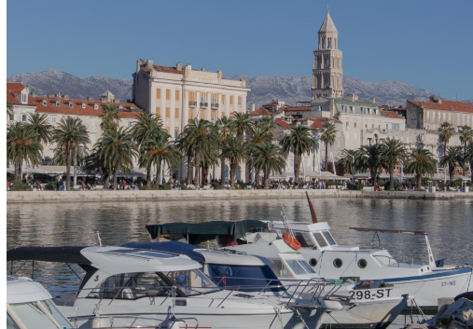

Figure 1. Times New Roman, 11 pt., justified. Replace the photo of Split with any figure that illustrates the scientific content of your contribution. Provide a short description of the figure, including labels and scale markers as appropriate.

[1] R Ablett, *Phil. Mag.* **46** (1923), 244.

[2] F Author in *“Introduction to abstract writing”*, ed. D Writers, (Publisher, City, year) first page.